1971
and

Convertible Registry

Eric L. Stevens
429 Apache Run
Wallisville, TX 77597
(409) 389-8346
Email: GTOEric71@yahoo.com

Thank you for responding to this registry. Its purpose is to verify and record how these automobiles were built and how many are still in existence.
It will also bring together those of us with a common interest in preserving this piece of automotive history.

Please understand that all numbers (VIN #s, Body #s, etc.) requested are for verification purposes only, and will be kept STRICTLY CONFIDENTIAL.
Only generic information will be shared among registry members or others.

This registry is provided as a service by a fellow GTO enthusiast.

Your Name __________________________________________________

Address __________________________________________________

City, State, Zip __________________________________________________

Email Address __________________________________________________

Phone # __________________________________________________

If you notice any incorrect or incomplete information on this form, please contact me so I may update it.

Please include a copy of your invoice and a photo(s) of your car when returning this form.
Cars are listed in the registry as “Confirmed” or “Unconfirmed”. The only way to have your car listed as “Confirmed” is to provide a copy of the invoice.

Available Options:

Type GTO Judge

Codes

Size H.P. Comp. Ratio RPO UPC

Engine 400 ci (Standard) 300 8.2:1 34K L78
455 ci (Optional) 325 8.2:1 34P L75
455HO (Optional) 335 8.4:1 34U LS5

Transmission 3 Speed Manual (Standard) 35C M13
4 Speed Manual (Optional) Wide Ratio 35E M20
4 Speed Manual (Optional) Close Ratio “Rock Crusher” 35G M22
Hydramatic (Optional) 35L M40

Axle Ratio 3.07-12 3.08-10 3.23-10 3.31-12 3.55-10
3.55-12 3.90-12 4.33-12 Other__________

Paint Colors Starlight Black A 19
Sandalwood B 61
Cameo White C 11
Adriatic Blue D 24
Lucerne Blue F 26
Limekist Green H 42
Tropical Lime L 43
Laurentian Green M 49
Rosewood N 78
Nordic Silver P 13
Cardinal Red R 75
Castillian Bronze S 67
Canyon Copper T 62
Quezal Gold Y 53
Aztec Gold Z 59

Top Colors White 1 A
Black 2 B
Sandalwood 5 E
Dark Green 9 I

Upholstery Blue 261
Ivory 262
Sienna 264
Black 269

RPO UPC

Accessories Additional Fuel For Delivery ___ W84

Air Cleaner, Dual Stage Heavy Duty 422 K45
Air Conditioning, Manual 582 C60
Airfoil, Decklid, Flat Black (Judge Only) 604 WT7
Axle, 3.55:1 Ratio ___ H02
Axle, Saf-T-Track 361 G80
Axle, Special Order 362 G83/G94
Axle Ratio, Economy 364 G95/G97
Axle Ratio, Performance 368 G90/G92
Basic Option Group 321 Y88
(C/O: Hydramatic Transmission, G70X14
White Letter Tires, AM Radio, Custom Wheel
Covers, Power Steering, Power Disc Brakes
and Electric Clock)
Battery, Heavy Duty 692 UA1
Battery, Maintenance Free 654 TPI
Brakes, Power Disc 502 JL2
Bumper Guards, Rear 734 ___
Canadian Base Equipment Modification 752 Z49
Clock, Electric 722 U35
Console 431 D55
Cruise Control 711 K30
Door Locks, Power 554 AU3
Door Locks, Power (with Seat Back Locks) 552 AU5
Flashlight, Self-Charging (Utility Light) 691 WU1
Gauges, Rally, with Clock 718 W63
Gauges, Rally, with Clock and Tach in Dash 714 U30
Glass, Soft-Ray Tinted (All Windows) 531 A01
Glass, Soft-Ray Tinted (Windshield Only) 532 A02
Guards, Door Edge 492 B93
Headlamp Delay 654 T81
Judge Package 332 WT1
(C/O: 455HO Engine, De-Chromed Rally II
Wheels, Ram Air Induction, Ride & Handling
Suspension, G70X14 Blackwall Tires, T-Handle
Shifter (with Manual Transmission), Rear
Decklid Airfoil, Judge Stripes and Decals, Ram
Air Decals and Black Textured Grille)
Lamp, Luggage Compartment 662 U25
Lamp, Underhood 671 U26
Lamps, Warning 652 W74
Mats, Front Floor 521 B32
Mats, Rear Floor 522 B33
Mirror, Outside Sport (Pair-Left Remote) 434 D35
Mirror, Outside Remote (Left Only) 444 D33
Mirror, Visor Vanity (Left) 442 DH5
Mirror, Visor Vanity (Right) 441 D34
Mouldings, Body Side 494 B84
Mouldings, Wheel Opening 491 B96
Paint, Special Order (Single Color) ___ SPS
Radiator, Heavy Duty 701 V01
Radio, AM 401 U63
Radio, AM/FM 403 U69
Radio, AM/FM Stereo 405 U58
Ram Air Induction System (455HO Only) 601 WU3
Rear Seat Speaker 411 U80
Safeguard Speedometer 712 U15
Seat, Power Bucket (Driver’s Only) 564 A46
Seat Belts, Custom 454 A39
Seat Belts, Custom, w/ Front Shoulder Straps 451 AK7
Seat Belts, Custom, w/ Front & Rear Shoulder Straps 452 AK2
Spare Tire Cover 424 P17
Spare Tire, Space Saver 684 N65
Steering, Power 501 N41
Steering Wheel, Custom Sport 462 N31/N34
Steering Wheel, Formula 464 NK3
Steering Wheel, Tilt 504 N33
Stripes, Rally 614 D98
Suspension, Heavy Load 622 F40
Suspension, Ride & Handling 621 Y96
Tachometer, Hood 721 UB5
Tape Player, Cassette 414 U55
Tape Player, 8-Track 412 U57
Tires, G70X14 White Wall Fiberglass TPR PX8
Tires, G70X14 White Letter Fiberglass TPL PK5
Trailer Group, Medium Duty 642 V82
Trunk Release, Power 421 A90
Wheels, Honeycomb (Rally III) 478 P05
Wheels, Rally II 474 N98
Wheels Covers, Custom 472 P02
Wheels Covers, Wire Disc 473 N95
Windows, Power 551 A31

Dealer ___________________________________________________________________________
Installed ___________________________________________________________________________
Accessories ___________________________________________________________________________
___________________________________________________________________________
___________________________________________________________________________

Condition Excellent
Good
Fair
Basket Case

Original Unrestored
Restored
Currently Undergoing Restoration

Mileage __________ Miles

Please provide some background on your car (when and where you got it, why a ’71, previous owners, etc.):

Did You Know?

- 1971 was the last year for the GTO convertible.
- 1971 was the last year for the Judge option (it was dropped after February, 1971).
- All 1971 GTO convertibles were built at the Pontiac, Michigan assembly plant.
- 1971 was the last year for the GTO as a separate series (it reverted to option status on the LeMans in 1972).
- 1971 was the lowest production convertible of any year GTO.

You can now easily verify the authenticity of your car and options. Pontiac Historic Services will provide:
- A copy of the factory invoice or billing history.
- A letter decoding the options.
- A copy of the dealer order form for that year.
- An official photo (if available).
- Other specific information (where available).

Just send your VIN # and $50.00 ($60.00 Int’l.) to:

PHS Automotive Services, Inc.
P.O. Box 884
Sterling Heights, MI 48311-0884

NEW! Now you can fill out the online form and fax it to PHS for a quick response. Fax the form with your credit card information authorizing a $65.00 total fee to (248) 583-0596 and you will receive by fax back the invoice/billing history. The balance of the packet will be sent by mail.

1971 GTO Convertible Production

Engine Transmission GTO Judge Total
400-4bbl. Manual 79 0 79
400-4bbl. Automatic 508 0 508

455-4bbl. Manual 0 0 0
455-4bbl. Automatic 43 0 43

455-HO Manual 18 3 21
455-HO Automatic 13 14 27

The 3 Judge convertibles with manual transmission were all 4 speeds.

Standard convertibles 661
Judge convertibles 17

Total 1971 GTO convertibles 678

The VIN Plate is located on the left hand top of the instrument panel, which is visible through the windshield.

242671P100001
2=Division (Pontiac)
42=Series Number (GTO)
67=Body Style (Convertible, 2 door)
1=Year (1971)
P=Assembly Plant (Pontiac, MI)
100001=Serial Number (Serial Numbers starting with 100001 to be used for all V8 engines. Numbers are to be used in consecutive order regardless of series number).
Please fill out the following from your car: 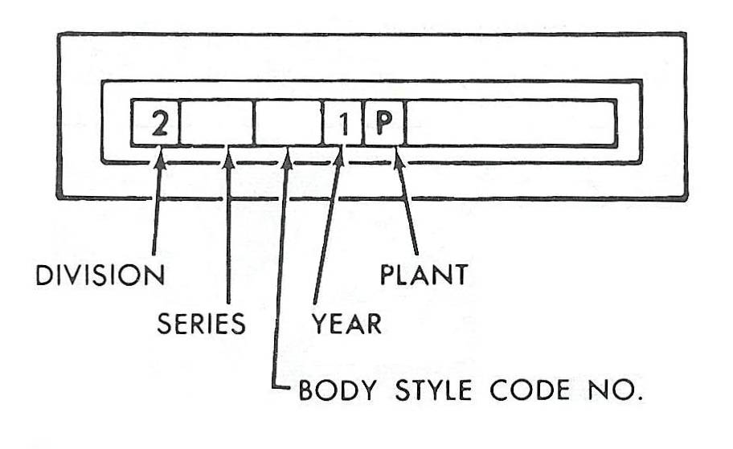
The Data Plate is located on the left hand top of the cowl, near the hood hinge.

BODY BY FISHER
ST 71 24267 PON 016952 BDY
TR 264 67 E PNT
12B
GENERAL MOTORS CORPORATION
CERTIFIES TO THE DEALER THAT THIS
VEHICLE CONFORMS TO ALL U.S. FEDERAL
MOTOR VEHICLE SAFETY STANDARDS
APPLICABLE AT TIME OF MANUFACTURE
ST 71 (1971=Model Year), 24267 (2=Pontiac, 42=GTO, 67=Convertible, 2-door)
PON Assembly Plant (Pontiac, MI)
BDY Fisher Body Unit Number (016952)
TR Trim Combination Number (264=Sienna Interior)
PNT Lower Body Color (67=Castillian Bronze), Upper Body Color or Fabric Color (E=Sandalwood Convertible Top)
12B Time Built Code (12=December, B=2nd Week)
Please fill out the following from your car:
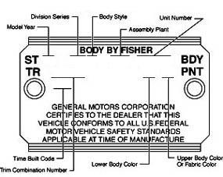

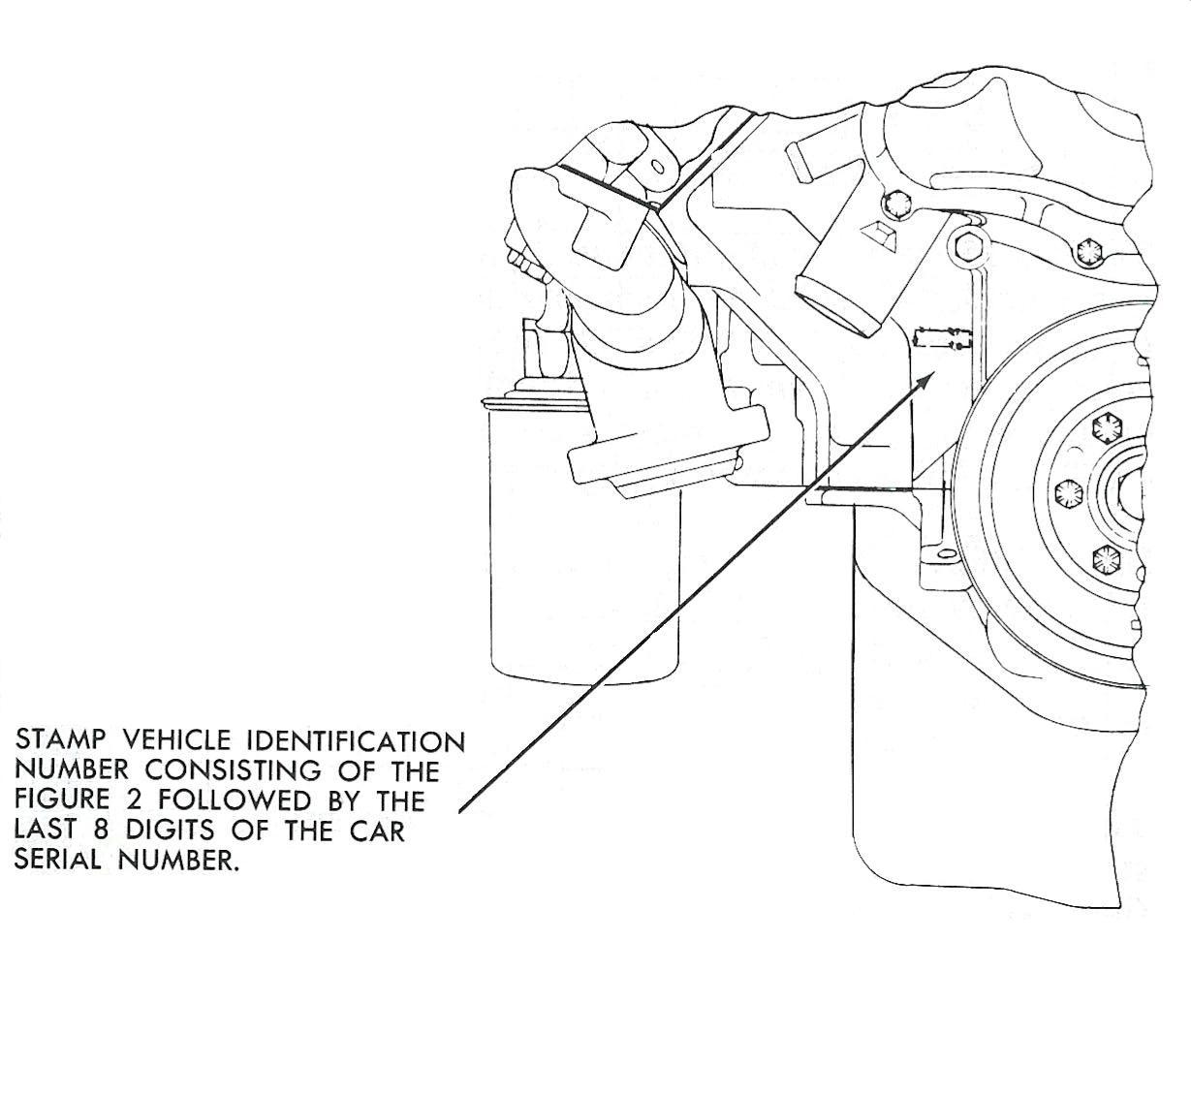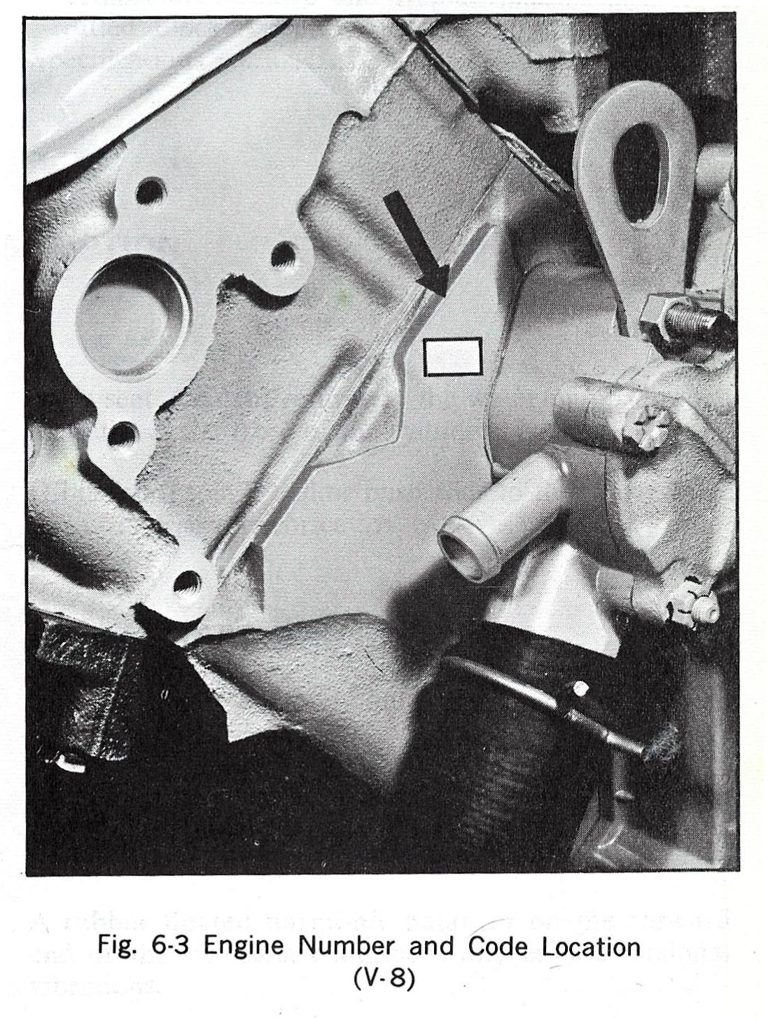

Engine Description | Code | Engine Description | Code
400 w/3Spd Manual | WT | 455HO w/3Spd Manual | WL
400 w/4Spd Manual | WK | 455HO w/4Spd Manual | WC
400 w/Turbo 400 | YS | 455HO w/Turbo 400 | YE
455 w/Turbo 400 | YC

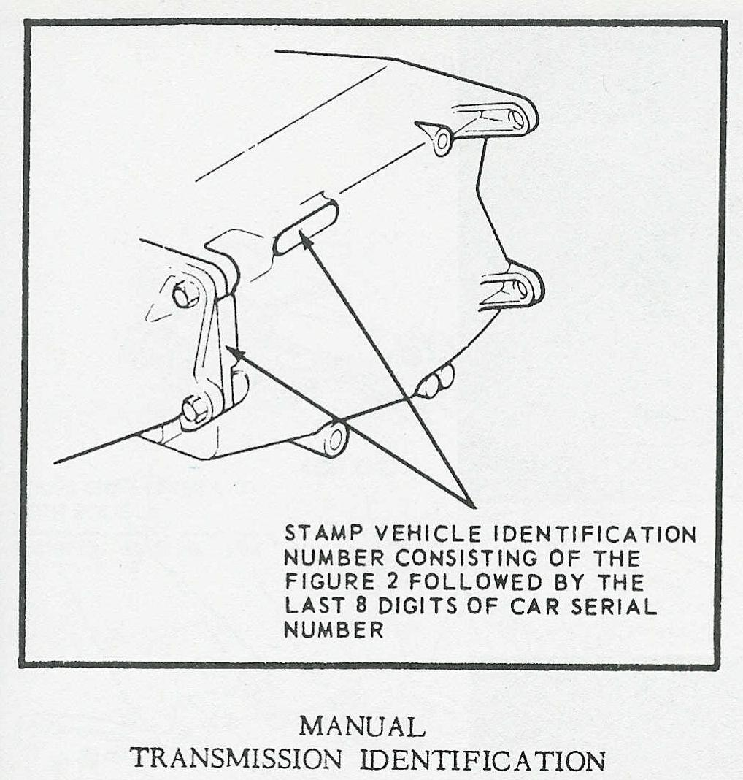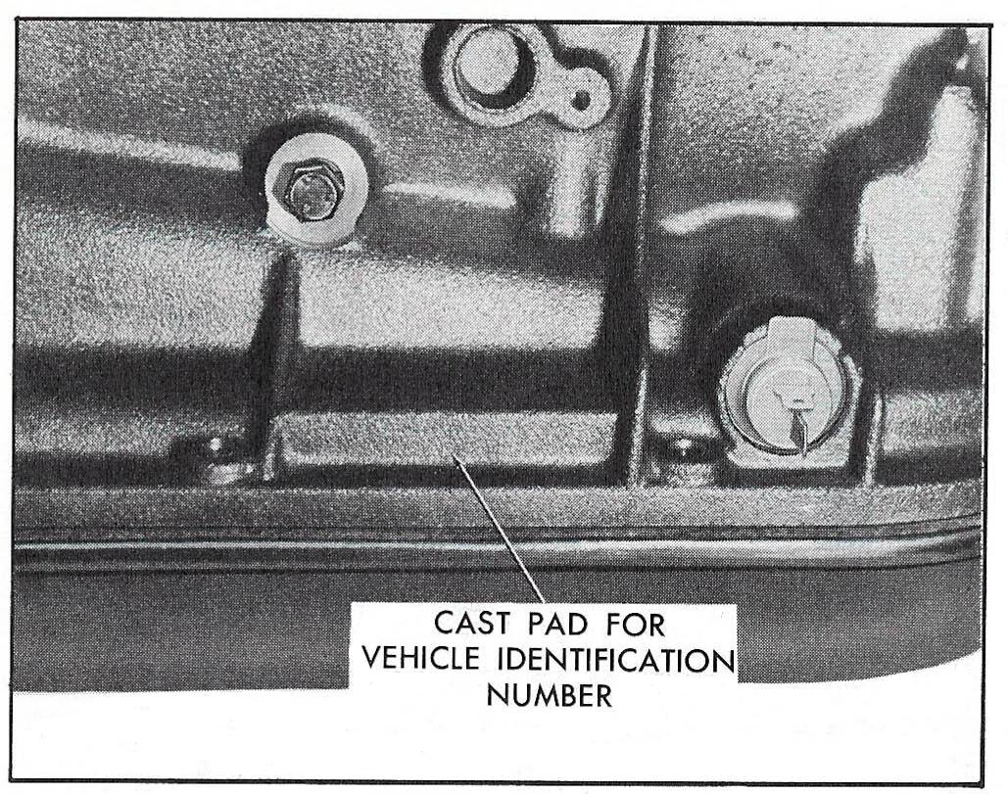

Turbo-Hydramatic M40

Turbo-Hydramatic M40 Code/Serial Number Location

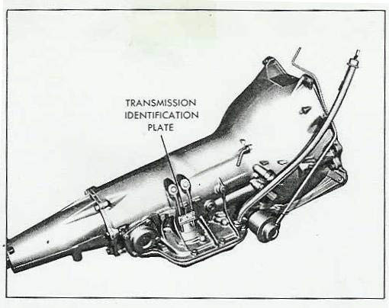
Transmission | Code
Three-Speed Manual (M13) | RM
Four-Speed Manual Wide-ratio (M20) | WT
Four-Speed Manual Close-ratio (M22) | WO
Turbo-Hydramatic (M40)(400 w/3.08-3.23) | PX
Turbo-Hydramatic (M40)(455 w/3.07) | PW
Turbo-Hydramatic (455HO) | PQ

Axle Codes

Gear Ratio | Open Rear | Safe-T-Track | # Bolts
3.07:1 | WTK | XTK | 12
3.08:1 | WEP | XEP | 10
3.23:1 | WFP | XFP | 10
3.31:1 | WUK | XUK | 12
3.55:1 | WHP | XHP | 10
3.55:1 | WVK | XVK | 12
3.90:1 |  | XKP/XPP | 12
4.33:1 |  | XMP | 12

The last letter denotes the axle manufacturer: P = Pontiac, K = GM of Canada.
The last letter does not appear on the axle tube (that I have seen).

